History 177: The United States Since 1877 Fall 2019

Class Meeting Times: Section 1 11:00-11:50 MWF CCC 128  Section 2 1:00-1:50 MWF CCC 227  Office Hours:  Tuesday and Thursday, 1-2pm | Dr. Neil Prendergast  nprender@uwsp.edu  473 Collins Classroom Center

Freedom is the most contested idea in American history. Its widespread use in today’s political culture derives from a long past in which Americans—of all types—turned to the word as a symbol for their many hopes and dreams. In this course, we will ask a seemingly simple question: What does freedom actually mean?

As we will see, Americans have defined the word in several different ways, often depending on their own circumstances. As we investigate the meaning of this uniquely American word, we will tour the nation’s past. On our trip, we will see that not only did Americans in different time periods use “freedom” differently, but Americans in the same time period often fought over the word.

The goal of this tour is to leave us with an understanding that the vocabulary of our public culture is the result of not only our hopes and dreams, but also long-lasting battles over the meaning of America.

Enduring Understandings

- Americans have long fought over the meaning of freedom.

- Understanding why Americans fight about the meaning of freedom widens our perspective of diverse American experiences.

Learning Outcomes After taking this course, students will be able to:

- understand how ‘freedom’ became a central idea in modern American culture
- describe changes to American government, culture, and society
- synthesize information to understand social context

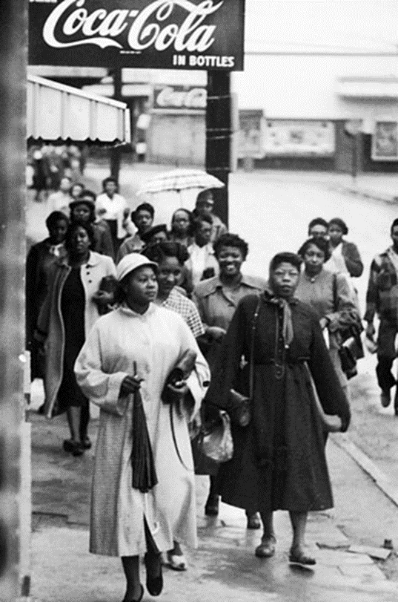 | 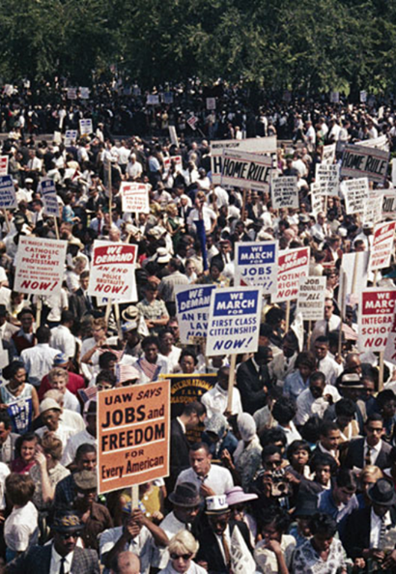 |  | 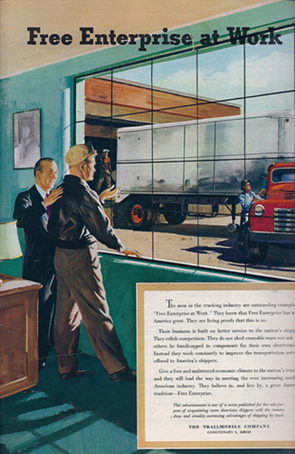 |  | Although we think of the 1950s and early 1960s as a time of peace and prosperity, Americans were then passionately engaged in debating the meaning of freedom.
Required Materials: For this course, you need the two books listed below as required. In addition, there will be PDF’s posted on D2L that will also be required reading.
From Text Rental at the University Bookstore  Who Built America? Working People and the Nation’s History, Third Edition, Volume 2 (Boston and New York: Bedford St. Martin’s Press, 2008).This is our textbook for the semester.  Eric Foner, Voices of Freedom, Volume 2, Third Edition. |  |  |  | 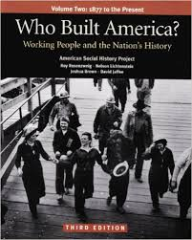 |  | 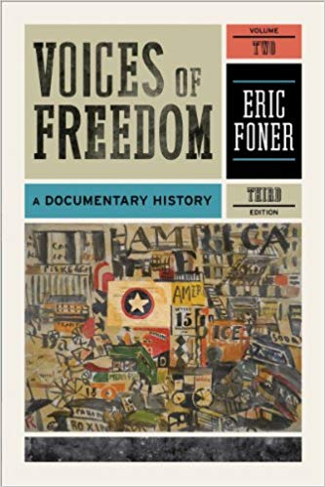  REQUIRED
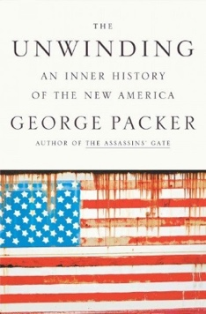  RECOMMENDED |  | Recommended Book Each semester I receive great questions about how the past is connected to the present. As a response, I have gradually shifted my teaching so that it explores new themes and investigates more recent history. Still, there is always more to learn. For those students wanting an expansive view of the last thirty years, I highly recommend George Packer’s The Unwinding: An Inner History of the New America. The book is less about specific political events and more about the mood and changing beliefs of the nation. At the end of the semester, an optional extra credit assignment is available for those who read this book.

Reading in a College History Course: In this course, 40-50 pages of reading a week is common. For many people, that amount will be a lot. So, how do you as a student deal with that?

First, there are some basic reading tips that will help: 1) read in a distraction-free environment, especially one without a smartphone nearby; 2) as you read, take notes or make notations on the page to engage better with the reading; 3) read at a time of day when your brain wants to read.

Second, you may need to fine tune your goals for reading history. The Voices of Freedom book requires a close read where you think carefully about the author’s choice of words. These readings are, fortunately, short. The Who Built America? textbook readings are longer but do not require the same, time-consuming close read. Pay close attention to passages containing key words from my study guide or that fill in a gap in your own understanding. Read the rest of the assigned pages but not with the expectation that you will have to repeat every detail back on an exam.

Finally, budget your time. Schedule four or five hours a week to read for this course. University guidelines say two hours outside class should be spent preparing for one hour in class. Actually schedule those hours into your week.

Course Structure: In brief, here’s the layout of the course.

Units: The course has five units, each ending with a quiz that includes multiple choice and some writing.

Quizzes: We have five quizzes: one quiz approximately every three weeks. Each question on the quiz will correspond to one day’s material. On normal class days, I will pose a question that we will answer via textbook reading, document reading, lecture, and discussion. You will see this same question on the quiz as a multiple choice question. After answering it on the quiz, you will have to write a paragraph explanation using key terms. This structure will become habit and is easily understood once we get going in the first week or so.

Papers: There are two papers. Each asks you to discuss American history in reaction to how someone today uses it. Prompts will become available in the first weeks of the course. You may turn in these papers whenever you like, but to revise them for a higher grade (which is possible!), you must have them done by April 15th.

Extra Credit: Five extra credit points are available at the end of the semester for successful completion of a paper regarding George Packer’s The Unwinding: An Inner History of the New America.

Tips from Previous Students in My U.S. History Courses:

“Come to class with an open mind. It’s not the same class you took in high school.”

“Take your own notes with your own thoughts, so you aren’t just copying down the slideshow.”

“Show up to class every day because it’s really fun and you could learn a lot.”

“Keep up on your reading.”

“Take notes on the chapter and try to relate each section of the chapter to the question each week.”

“Read the chapters ahead of lecture because it makes the lectures more interesting and you will have a better understanding of the material.”

“Take the reading seriously.”

“Read, Read, Read! But don’t try to capture every detail. Look for evidence to help with your argument.”

Grade Formula and Scale:
Five Quizzes (20 points each)
Twenty Regular Work Assignments (2 points each)
Two Papers(30 points each )
200 points

+ 5 possible extra credit points
205 possible points

I use a standard grade scale: letter grades below correspond to percentages of points earned.

A 93-100 | B+ 87-89.99 | C+ 77-79.99 | D+ 67-69.99 | F 59.99 and below
A- 90-92.99 | B 83-86.99 | C 73-76.99 | D 60-66.99
 | B- 80-82.99 | C- 70-72.99

Notetaking: Some wonderful tips for exam studying are available at UWSP’s Learning and Tutoring Center http://www.uwsp.edu/tlc/ and online via the University of North Carolina http://www.unc.edu/depts/wcweb/handouts/essay-exams.html

For notetaking, consider using the Cornell Method:
http://coe.jmu.edu/learningtoolbox/cornellnotes.html

Examples of student notes are available on D2L.

Extra Credit: For five possible extra credit points, students may read The Unwinding and write a paper following the guidelines here.

In 1500-2000 words, answer the following question: How has our country changed in the last thirty years? Papers must be typed in 12 point, Times New Roman font with normal Microsoft Word margins and settings. Papers may be turned in as either .docx or .pdf documents only. When discussing a passage from The Unwinding or any other book, a citation must be made (any citation style is fine).

Your response should consider to what degree the following course themes played a role: labor movement, free enterprise, changing gender roles, government regulation, and government as a social safety net. An easy way to outline your essay is to dedicate one paragraph to each of the five themes above, then add another one or two for the introduction and another one or two for a conclusion. To take notes as you read and that will then become useful in writing the paper, consider keeping track of where you see each theme appear in the book. Some will be there much more often than others.

Papers will be assessed according to their persuasiveness, clarity, fairness to the reading, and demonstrated understanding of course themes.

The assignment is especially aimed at students who have worked hard all semester but for one reason or another have not scored as high on the exams as they expected or would have liked. Since the paper requires students to apply what they have learned, the paper is an opportunity to display that knowledge. And because it demands an analytical approach to writing—as opposed to a mere summary of events—the paper forces higher level thinking that warrants a higher semester grade. Due at the end of our final exam time period.

Life Happens: I understand that life might make it difficult to complete some assignments, attend class, or simply to do well. I do my best to be flexible because I know those circumstances are out of your control and my control. I’m on your team. I also know that some real learning has to take place in this class. You will have more opportunity in life if you understand history, read critically, and write well. This class has to be one of your priorities. I do my best to be flexible, but I have to adhere to some standards. If something comes up, let’s talk.

Office Hours: You are welcome to visit me during office hours. I set aside office hours so that I have the chance to talk with students one-on-one. Tuesday and Thursday, 1-2pm, 473 CCC.

Course Policies: During the class, I strongly prefer that students do not use a smartphone, laptop, or other electronic device. If you are a parent or are otherwise obligated to be available to your family via cell phone, then please discuss that situation with me, so I know that you have a good reason for keeping your phone turned on.

The prohibition of electronics also extends to laptop computers (unless approved by the Disability Services Office). While laptops are great aides in studying, the focus in class is on class, not the computer screen. Further, the ability to take notes longhand is actually an important skill to develop, one that will be useful in any career you choose. If you do prefer to have your notes in a computer file, you will find that typing them from your handwritten notes will aid you greatly in digesting the material.

For information on plagiarism, consult http://www.uwsp.edu/centers/rights. See Chapter 14, Student Academic Standards and Disciplinary Procedures, pages 5 -10, for the disciplinary possibilities if you are caught cheating. As an instructor deeply concerned with fairness in the classroom, I pursue each and every case of plagiarism and cheating. Please note that turnitin.com is used for typed assignments.

Equity of Educational Access: If you have a learning or physical challenge which requires classroom accommodation, please contact the UWSP Disability Services office with your documentation as early as possible in the semester. They will then notify me, in a confidential memo, of the accommodations that will facilitate your success in the course. Disability Services Office, 103 Student Services Center, Voice: (715) 346-3365, TTY: (715) 346-3362, http://www.uwsp.edu/special/disability/studentinfo.htm.

 | 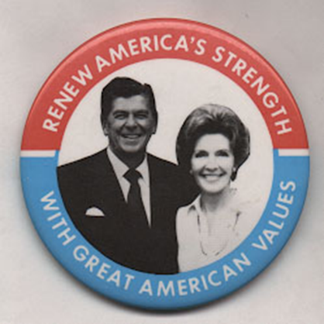 | 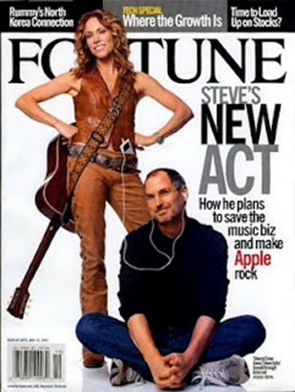
The 1970s saw an economic slump that opened the way for rethinking freedom. A conservative turn in American politics during the 1980s promised a “free market” economy. The digital economy held to the “free market” idea, but failed to create the same living wage jobs for Americans that had made manufacturing so beloved a generation before.

Note: The syllabus is a general plan for the course. Deviations announced in class may be necessary.

Schedule:
Week 1 |  | Wednesday  Course Introduction | Friday  Introduction to 20th Century
Reconstruction Textbook Pages to Review for this Topic: Who Built America, 4-14
Week 2 | Monday “Petition of Comm,” VF | Wednesday “Mississippi Black Code,” VF | Friday “Sharecropping Contract,” VF
Industrialization WBA 26-48, 91-120, 134-144, 255-269
Week 3 | Monday “William G. Sumner,” VF | Wednesday “Living Wage,” VF | Friday “Populist Party Platform,” VF
 |  | Great Depression WBA 394-438, 445-454, 480-488
Week 4 | Monday Reconstruction and Industrialization Quiz | Wednesday | Friday “Franklin Roosevelt ‘Greater Security,” VF
 |  | World War II WBA 497-547
Week 5 | Monday “Herbert Hoover on New Deal,” VF | Wednesday “Franklin Roosevelt on Four Freedoms,” VF | Friday “World War II and Mexican Americans,” VF
Week 6 | Monday “African Americans and the Four Freedoms,” VF | Wednesday “Justice Robert A. Jackson, Dissent,” VF | Friday Great Depression and World War II Quiz
Postwar Liberalism WBA 556-567, 580-605, 626-636
Week 7 | Monday “NSC 68,” VF | Wednesday “Clark Kerr, ‘Industrialism,” VF | Friday “Port Huron Statement,” VF
Civil Rights Movement WBA 616-625
Week 8 | Monday “President’s Commission on Civil Rights,” VF | Wednesday “MLK and Montgomery Bus Boycott,” VF | Friday “Cesar Chavez, ‘Letter from Delano,’” VF
 |  | Postwar Conservatism WBA 567-580
Week 9 | Monday Postwar Liberalism and Civil Rights Quiz | Wednesday “Southern Manifesto,” VF | Friday “Milton Friedman, ‘Capitalism and Freedom,’” VF
 |  | Free Enterprise in the Seventies and Eighties WBA 684-726
Week 10 | Monday  “Sharon Statement,” VF | Wednesday  “Ronald Reagan, ‘Inaugural,”VF | Friday
Week 11 | Monday | Wednesday  “Bill Clinton, NAFTA,’” VF | Friday Postwar Conservatism and Free Enterprise Quiz
Gender in the Seventies and Eighties WBA 661-667, 700-707
Week 12 | Monday | Wednesday “National Org. for Women,” VF | Friday “Phyllis Schlafly, ‘Fraud,’” VF
Week 13 | Monday | Wednesday  TBA | Thanksgiving Break  No Class
Evangelical Politics TBA
Week 14 | Monday | Wednesday “Jerry Falwell, Listen!” VF | Friday
Digital Economy TBA
Week 15 | Monday | Wednesday | Friday Gender, Evangelical Politics, and Digital Economy Quiz
Week 16 Final Exams: Visit AccessPoint for final exam times.

